[Arduino to Motor Controller to Hub Motor Wiring](https://drive.google.com/open?id=0BySJuScrlj2OTzlJQk90bWZxaWc)

===================================================================

BEGIN SESSION I

Hub Motor US $39.99

1 item sold by [waynobobber](http://www.ebay.com/usr/waynobobber?_trksid=p2060353.m2749.l2754)

| [Pair of 6.5" Replacement Wheel Rim Tire For Mini Smart Unicycle Scooter Motor](http://www.ebay.com/usr/waynobobber?_trksid=p2060353.m2749.l2754)  Pair of 6.5" Replacement Wheel Rim Tire For Mini Smart Unicycle Scooter Motor  ( 152394938992 ) |
| --- |

**350W 5-36V Brushless Controller BLDC Wide Voltage High Power Three-phase**

**Seller information**

[**alicexi20**](http://www.ebay.com/usr/alicexi20?_trksid=p2047675.l2559) **(**[**12787**](http://feedback.ebay.com/ws/eBayISAPI.dll?ViewFeedback&userid=alicexi20&iid=263026371172&ssPageName=VIP:feedback&ftab=FeedbackAsSeller&rt=nc&_trksid=p2047675.l2560) **)**

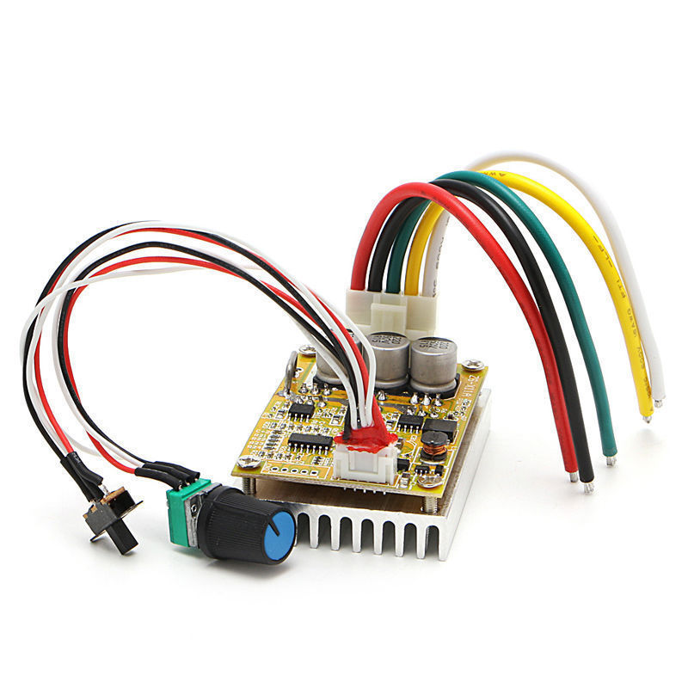

#### **350W 5-36V Brushless Controller BLDC Wide Voltage High Power Three-phase**

**Description:**

* 100% Brand New and High Quality
* Wide voltage 5-36V, high power 350W, with heat sink, Lead wire, control switch etc. can be used directly
* Feature:
* 1.MA MB MC phase line output connection motor
* 2 5V GND motherboard comes with original
* 3.VCC GND external DC power supply line
* 4.SC pulse signal output
* 5.Z/F positive inversion control line 5V or GND to achieve positive and negative inversion
* 6.VR speed signal input, the general external 100K tripod middle pin potentiometer VR the remaining two feet 5V and GND main board.
* Specifications:
* Working voltage: 5-36V
* Maximum current: 16A
* Maximum power: 350W
* Over current protection
* Size: length 63mm x width 45mm x height 27mm
* Quantity: 1 Set
* Note:
* Please allow 1-3mm error due to manual measurement. pls make sure you do not mind before you bid
* Due to the difference between different monitors, the picture may not reflect the actual color of the item. Thank you!

**Package includes:**

* 1 x Brushless Controller Set

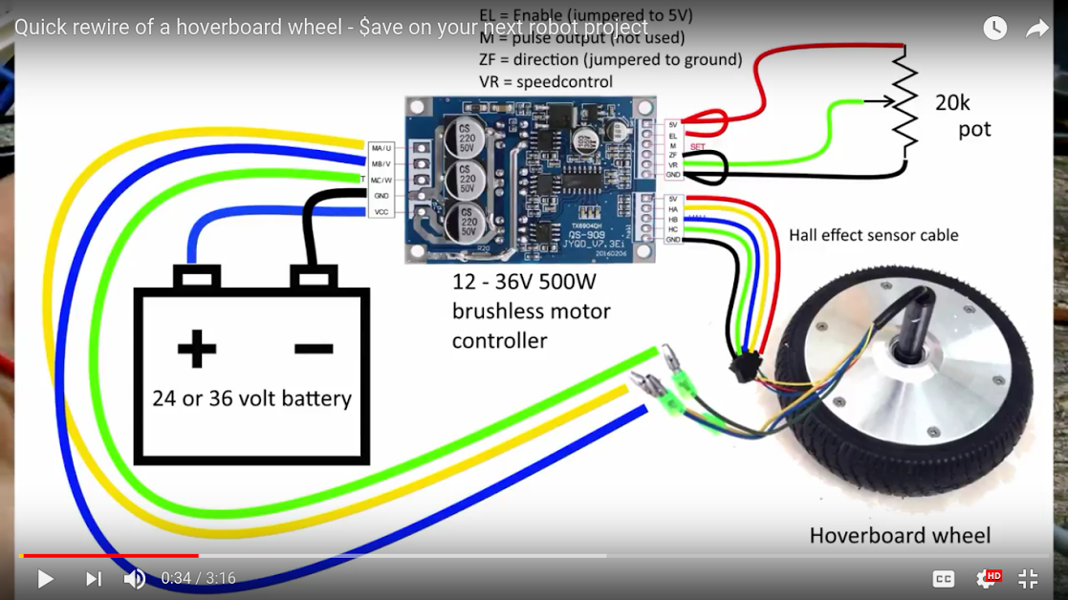

[Arduino Uno](https://www.arduino.cc/en/Main/ArduinoBoardUno)

[Voltage Divider Tutorial](https://www.allaboutcircuits.com/textbook/experiments/chpt-3/potentiometer-voltage-divider/)

[Wireless Remote Control](https://docs.google.com/document/d/1AaQmwKiLiiIFLeP8Kk19p4IfnDybd08enQUj-TCrXoc/edit?usp=sharing)

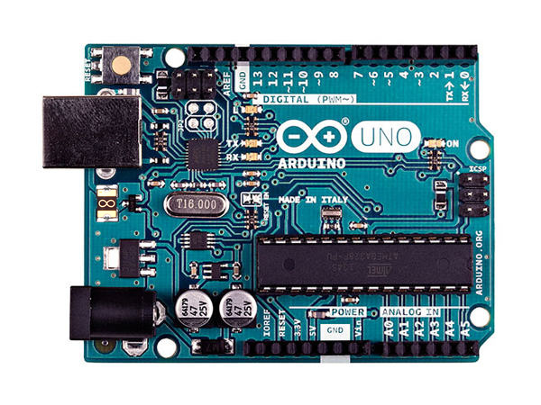

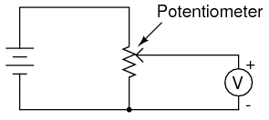

===================================================================

BEGIN SESSION II

Objective:

Demonstrate Rev 3 Control with heat sink controller

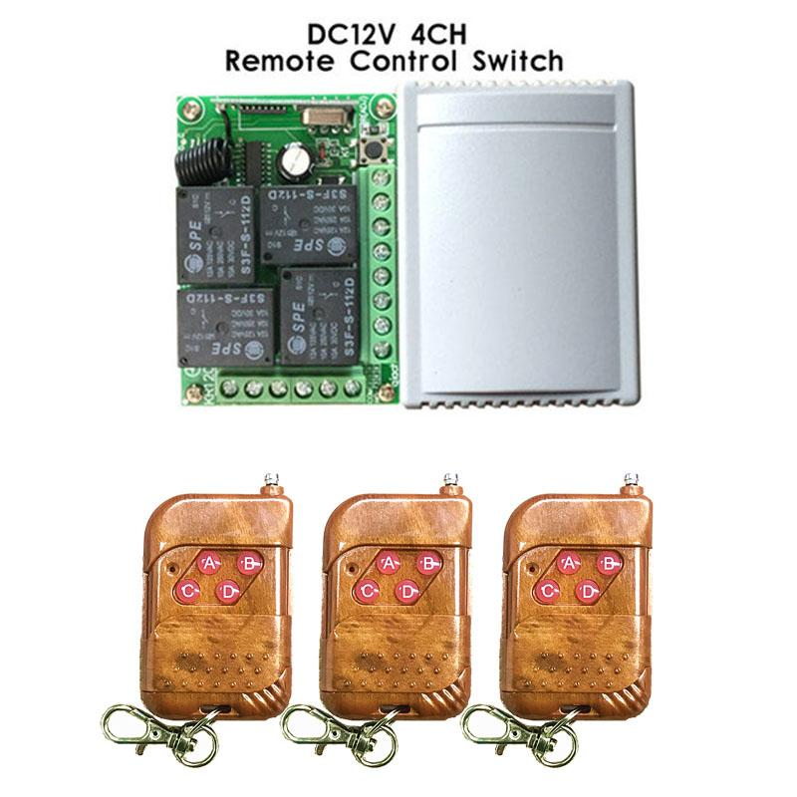

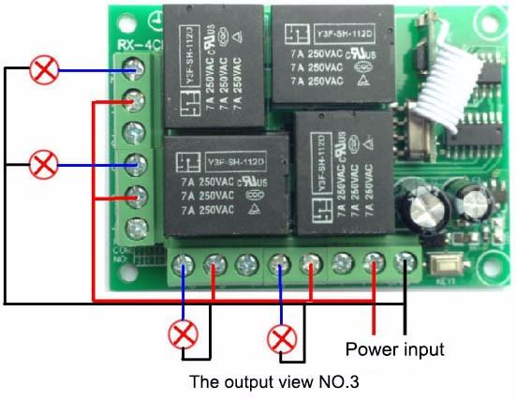

Wireless Remote Key Fob

[A. Wireless Remote Key Fob](https://docs.google.com/document/d/1AaQmwKiLiiIFLeP8Kk19p4IfnDybd08enQUj-TCrXoc/edit?usp=sharing)

1. Provided ground to each of the N.C. contacts.
2. At this point I applied power to the Zip motor (not on ground - no load)

This worked quite well in both directions.

1. Then I put the wheel used for propulsion in contact with the ground.
2. I was barely able to notice an attempt of movement. (the torque appeared to be very low).
3. What should I suspect the problem is and how should I debug the problem.

* 5s
* James McCrary's profile photo
* [James McCrary](https://plus.google.com/u/0/110298790876801135283)
* I am suspecting I need to increase the gear ration for more torque. I am current at 16T and 52T. I am looking at 7T and 80T found on 49 and 49 cc dirt bikes (25H chain). Ordered Today.
* 1s
* James McCrary's profile photo
* [James McCrary](https://plus.google.com/u/0/110298790876801135283)
* Houston, we have liftoff. I was able to accelerate the TCT. The bad news: It won''t go up hill. With the addition of a battery and airing up a flat tire the TCT did move. I am hoping the new gearing will get her up hill. 4.33 vs 12.857

TCT Wiring Diagrams Rev 2

Key Fob Wiring

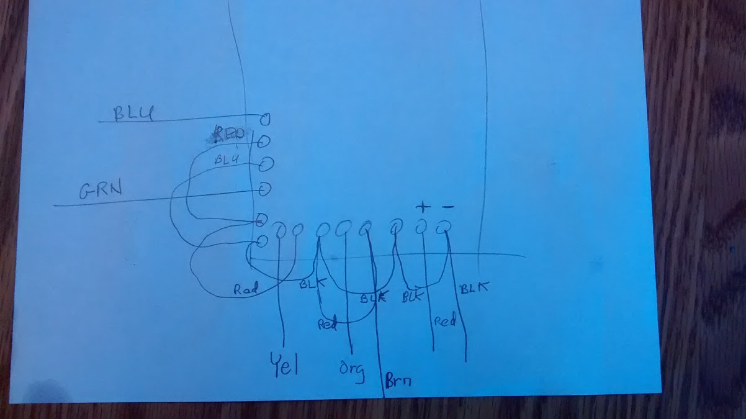

Latest Propulsion Control System Wiring 8/24/2012

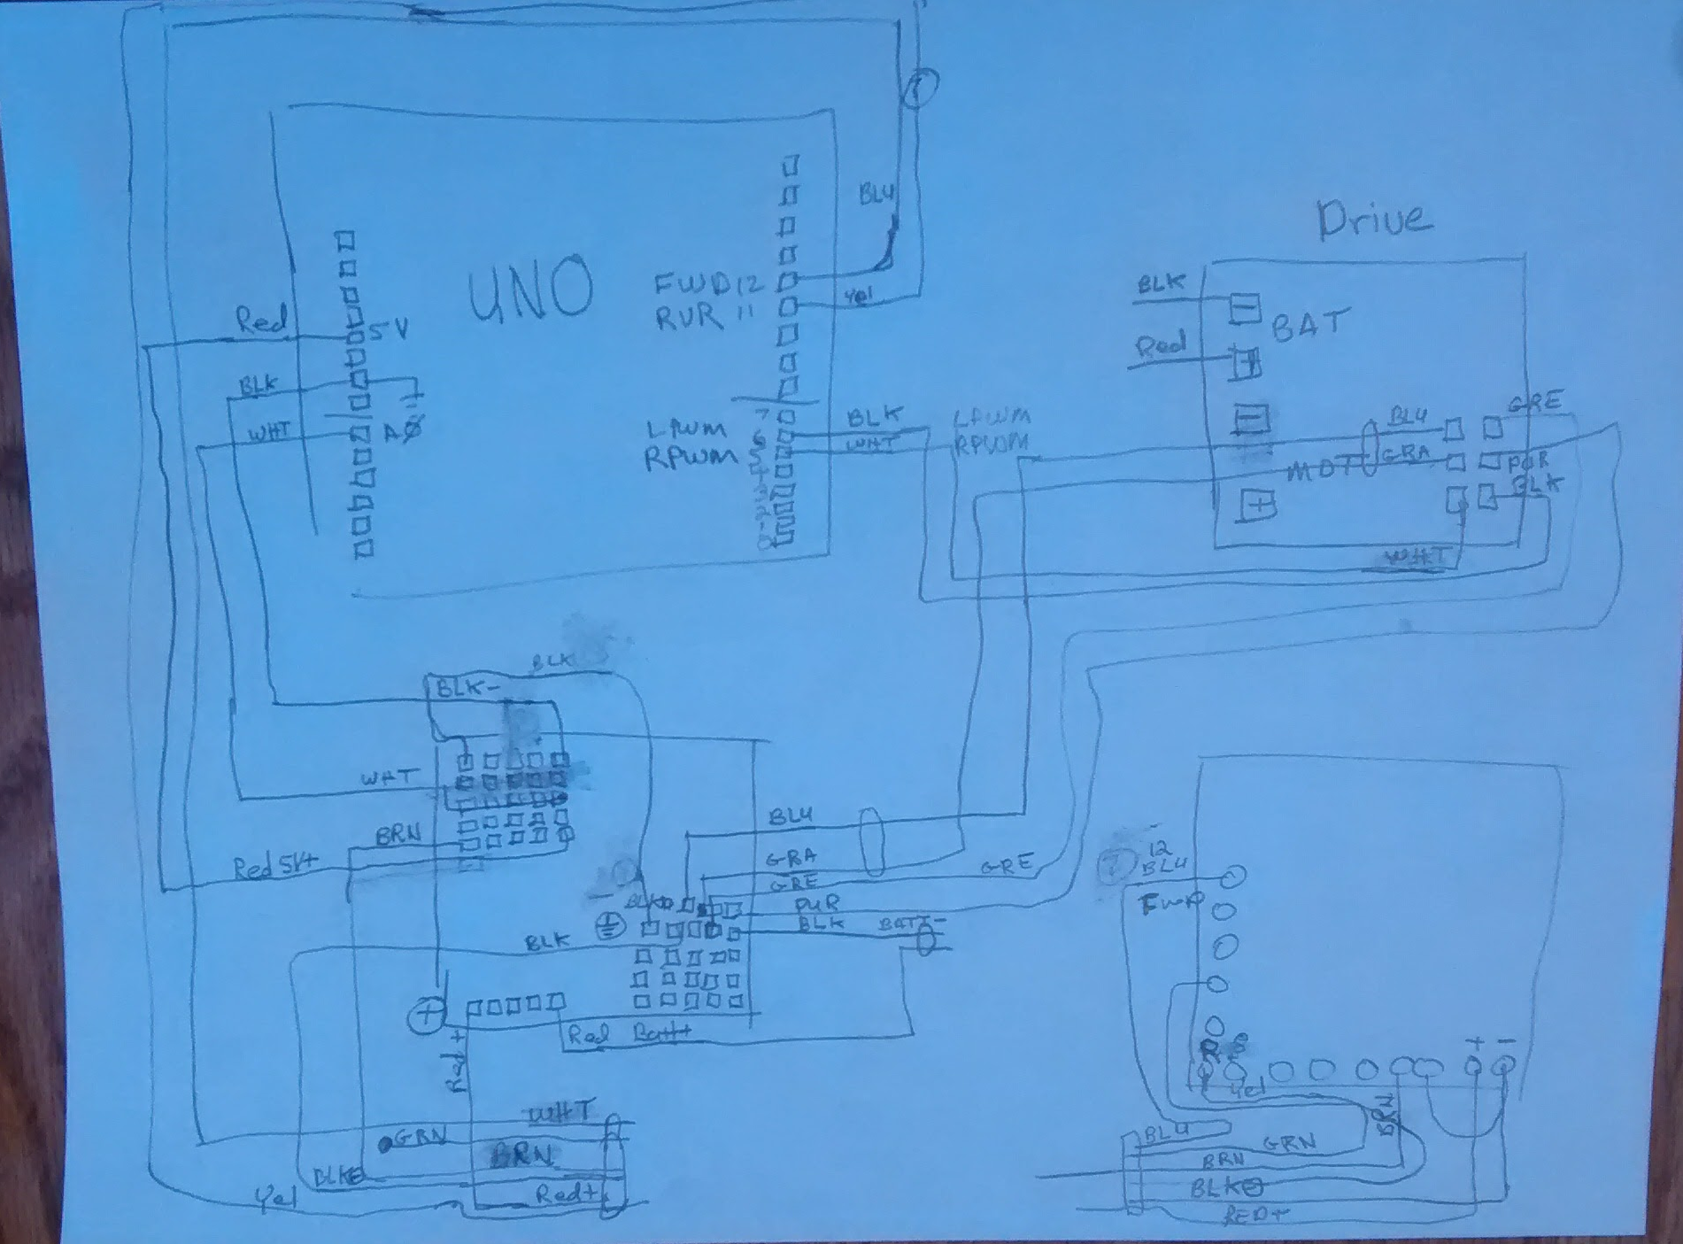

[Video of TCT in Motion with 24VDC System](https://photos.google.com/photo/AF1QipNQcm_T1wFc6Xpch7mt__IoYGL8gZuy0QlNEAYT)

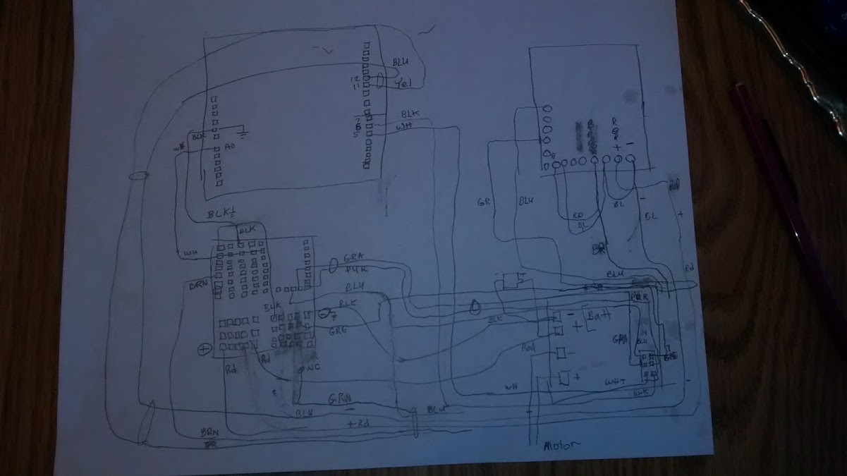

/*

IBT-2 Motor Control Board driven by Arduino.

20170331 Potientiometer taken out of code.

20170419 Wired Remote contacts (8) to inputs 11/12.

Had to add (-) connected to nc to prevent input floating.

Connection to the IBT-2 board:

IBT-2 pin 1 (RPWM) to Arduino pin 5(PWM)

IBT-2 pin 2 (LPWM) to Arduino pin 6(PWM)

IBT-2 pins 3 (R_EN), 4 (L_EN), 7 (VCC) to Arduino 5V pin

IBT-2 pin 8 (GND) to Arduino GND

IBT-2 pins 5 (R_IS) and 6 (L_IS) not connected

*/

// int SENSOR_PIN = 0; // center pin of the potentiometer

int zeroSpeed = 0; //

int maxReverse = 123; //

int maxForward = 123; //

int RPWM_Output = 5; // Arduino PWM output pin 5; connect to IBT-2 pin 1 (RPWM)

int LPWM_Output = 6; // Arduino PWM output pin 6; connect to IBT-2 pin 2 (LPWM)

int reverse_Input = 11; // Arduino Reverse Signal input (input from remote)

int forward_Input = 12; // Arduino Forward Signal input (input from remote)

void setup()

{

//Initialize serial and wait for port to open:

Serial.begin(9600);

pinMode(RPWM_Output, OUTPUT);

pinMode(LPWM_Output, OUTPUT);

pinMode(forward_Input, INPUT);

pinMode(reverse_Input, INPUT);

}

void loop()

{

int driveSetpoint;

driveSetpoint = zeroSpeed;

if (digitalRead(reverse_Input) == HIGH) // REVERSE rotation

{

driveSetpoint = maxReverse;

Serial.println("---> Reverse Selected");

int reversePWM = driveSetpoint;

analogWrite(LPWM_Output, 0);

analogWrite(RPWM_Output, reversePWM);

Serial.print("---> Reverse OUTPUT Selected: ");

Serial.println(reversePWM);

}

if (digitalRead(forward_Input) == HIGH) // FORWARD rotation

{

driveSetpoint = maxForward;

Serial.println("---> Forward Selected");

int forwardPWM = driveSetpoint;

analogWrite(LPWM_Output, forwardPWM);

analogWrite(RPWM_Output, 0);

Serial.print("---> Forward OUTPUT Selected: ");

Serial.println(forwardPWM);

}

if (digitalRead(forward_Input) == LOW && (digitalRead(reverse_Input) == LOW)) // FORWARD rotation

{

driveSetpoint = 0;

Serial.println("---> STOP SELECTED ");

analogWrite(LPWM_Output, 0);

analogWrite(RPWM_Output, 0);

Serial.print("---> STOP OUTPUT Selected: ");

// Serial.println(forwardPWM);

}

Serial.println("------------------------------------------------------------------------------");

delay(800);

}

/*

IBT-2 Motor Control Board driven by Arduino.

20170331 Potientiometer taken out of code.

20170419 Wired Remote contacts (8) to inputs 11/12.

Had to add (-) connected to nc to prevent input floating.

Connection to the IBT-2 board:

IBT-2 pin 1 (RPWM) to Arduino pin 5(PWM)

IBT-2 pin 2 (LPWM) to Arduino pin 6(PWM)

IBT-2 pins 3 (R_EN), 4 (L_EN), 7 (VCC) to Arduino 5V pin

IBT-2 pin 8 (GND) to Arduino GND

IBT-2 pins 5 (R_IS) and 6 (L_IS) not connected

*/

// int SENSOR_PIN = 0; // center pin of the potentiometer

int zeroSpeed = 0; //

int maxReverse = 123; //

int maxForward = 123; //

int RPWM_Output = 5; // Arduino PWM output pin 5; connect to IBT-2 pin 1 (RPWM)

int LPWM_Output = 6; // Arduino PWM output pin 6; connect to IBT-2 pin 2 (LPWM)

int reverse_Input = 11; // Arduino Reverse Signal input (input from remote)

int forward_Input = 12; // Arduino Forward Signal input (input from remote)

void setup()

{

//Initialize serial and wait for port to open:

Serial.begin(9600);

pinMode(RPWM_Output, OUTPUT);

pinMode(LPWM_Output, OUTPUT);

pinMode(forward_Input, INPUT);

pinMode(reverse_Input, INPUT);

}

void loop()

{

int driveSetpoint;

driveSetpoint = zeroSpeed;

if (digitalRead(reverse_Input) == HIGH) // REVERSE rotation

{

driveSetpoint = maxReverse;

Serial.println("---> Reverse Selected");

int reversePWM = driveSetpoint;

analogWrite(LPWM_Output, 0);

analogWrite(RPWM_Output, reversePWM);

Serial.print("---> Reverse OUTPUT Selected: ");

Serial.println(reversePWM);

}

if (digitalRead(forward_Input) == HIGH) // FORWARD rotation

{

driveSetpoint = maxForward;

Serial.println("---> Forward Selected");

int forwardPWM = driveSetpoint;

analogWrite(LPWM_Output, forwardPWM);

analogWrite(RPWM_Output, 0);

Serial.print("---> Forward OUTPUT Selected: ");

Serial.println(forwardPWM);

}

if (digitalRead(forward_Input) == LOW && (digitalRead(reverse_Input) == LOW)) // FORWARD rotation

{

driveSetpoint = 0;

Serial.println("---> STOP SELECTED ");

analogWrite(LPWM_Output, 0);

analogWrite(RPWM_Output, 0);

Serial.print("---> STOP OUTPUT Selected: ");

// Serial.println(forwardPWM);

}

Serial.println("------------------------------------------------------------------------------");

delay(800);

}

Alternate Drive Mechanism

